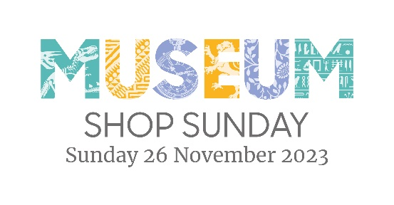
Your Logo

PRESS RELEASE
Date:
TITLE: <Your Organisation> Taking Part in Museum Shop Sunday
<Organisation name> is delighted to announce it will be taking part in Museum Shop Sunday on 26 November 2023, with lots of offers and discounts on some great gift ideas just in time for Christmas.
Museum Shop Sunday is an annual international campaign to highlight the vital role of retail in helping arts, cultural and heritage venues to survive and thrive. On Sunday 26 November, over 2,000 visitor attractions worldwide will be coming together to celebrate with special events and promotions in store and online.
<your organisation> is pleased to be part of Museum Shop Sunday as it is a great way to introduce new customers to our <a bit of detail about your organisation> and to show them the fantastic range of unique, hand-crafted <messages around sustainability, or maker stories are good here>.
We’re very proud of our range of gifts <insert some details of your offer, what will delight your customers, some of the original and unique gifts, items>
- What’s different about your range?
- What are some of the interesting stories of your merchandise?
- Are you supporting local makers?
- Do you use a green supply chain?
- Are there gifts in your shop that are unique to your organisation?
- Are there any special offers that you customers can enjoy on Museum shop Sunday?
<Insert a quote from your organisation here: e.g. <name, job title, said: “We are really pleased to be taking part in Museum Shop Sunday on 26 November as it is a great opportunity to welcome new customers to our venue. We have a fantastic range of lovely, hand-made <your USP here> and gifts purchased from our retail space are just two steps away from the person who actually made it from scratch …>
<Insert shop opening times and social media / website links so people can find out more about you and what you are doing for Museum Shop Sunday>
Ends:

Photo Descriptors:
Have two good, well-lit, high-res images to accompany your release, clearly labelled. Include as a WeTransfer or Dropbox link (journalists will not be happy with 20 MB attachments crashing their inbox!).
Make sure you have the creator’s permission to use the photos and label them accordingly, e.g. Photo credit: Albert Smith Photography.
If you have people in your photo label them left to right, e.g. L-R: Ellie Bloom, retail manager and George Pilcher, merchandising assistant get the retail space ready for Museum Shop Sunday.
<Insert contact details for further information and / or photos /interviews etc>

Notes to editors:
Use this section to talk about your organisation (the About Us section of your website is often a good place to find this).
About Museum Shop Sunday
Now in its seventh year, Museum Shop Sunday is an annual international campaign to highlight the vital role of retail in helping arts, cultural and heritage organisations to survive and thrive. Over 2,000 cultural shops take part each year worldwide, including around 200 in the UK, putting on special events and promotions online and in store to showcase their unique products. Museum Shop Sunday is organised by the Association for Cultural Enterprises, which champions best practice in cultural income generation.
#MuseumShopSunday
Instagram: @museumshopsunday
Twitter: @lovemuseumshops

