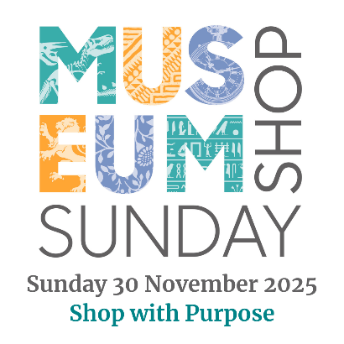 [insert your logo here]

Museum Shop Sunday Campaign Encourages Consumers
to Shop with Purpose this Christmas
<Organisation name> is delighted to announce it will be taking part in Museum Shop Sunday on 30 November, with offers and discounts on some great gift ideas just in time for Christmas.
Every year on Museum Shop Sunday over 2,200 arts, heritage and cultural attractions worldwide come together to showcase their fantastic shops and unique products with special events and promotions in store and online.
Museum Shop Sunday is all about Shopping with Purpose. When you choose to shop at <your organisation>, you are not just buying a gift – you are actively contributing to our work and maintaining our collections for future generations to enjoy. You’re also directly supporting the amazing local suppliers and independent makers that create the unique gifts available to purchase in our shop.
<Insert some info about your products and your Museum Shop Sunday offer>
- What’s different about your range?
- What are some of the interesting stories behind your products?
- Are you supporting local makers or craftspeople?
- Do you use a green supply chain?
- Are there gifts in your shop that are unique to your organisation?
- Are there any special offers or events that your customers can enjoy on Museum Shop Sunday?
<Quote from your organisation e.g. name, job title, said: “We are really pleased to be taking part in Museum Shop Sunday on 1 December. We have a fantastic range of lovely, hand-made gifts …. Etc.”>
<Opening times of your organisation for Museum Shop Sunday and your social media / website so people can find out more about you and what you are doing for Museum Shop Sunday>
Shop with purpose – discover unique products you’ll love and support your favourite cultural attractions on Museum Shop Sunday. To find out more, visit museumshopsunday.org.uk or follow @MuseumShopSunday on Instagram.
Ends:
<Insert 2-3 good quality images, clearly labelled. Include low res versions within the body of the press release, with a note that the high res versions along with further images can be supplied upon request>.
<Insert contact details for further information and / or photos /interviews etc>
Notes to editors:
<Use this section to talk about your organisation>
About Museum Shop Sunday
Now in its ninth year, Museum Shop Sunday is an annual international campaign celebrating cultural retail. Spearheaded in the UK by the Association for Cultural Enterprises, the campaign aims to highlight the vital role of retail in generating income for arts, heritage and cultural organisations of all sizes and types – especially in the face of recent funding cuts and other economic challenges. Find out more at museumshopsunday.org.uk or follow @MuseumShopSunday on Instagram.

